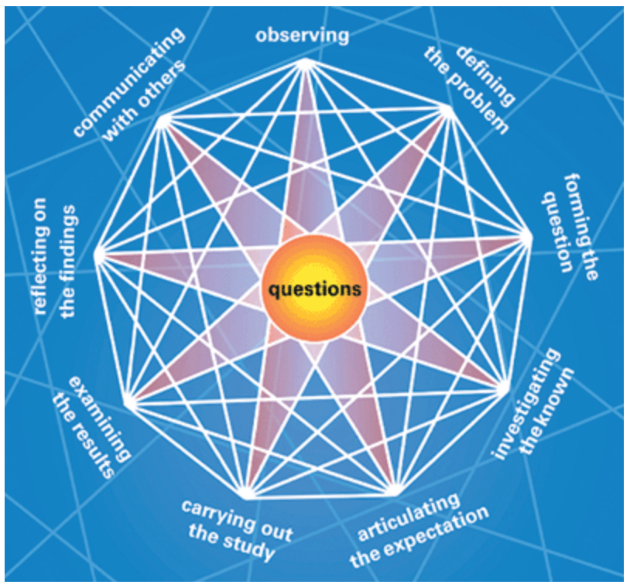

|  |  |  |
| --- | --- | --- |
| Contextualize your work | | |
| Exploration: | | |
| Curiosity-driven questions: | | |
| Define the problem: | | |
| What do I already know? | | |
| Map your inquiry: | | |
| Stage | Your ideas | |
| Investigate the known | *What information do you need?*  *Where can you find it?*  *What method will you use?*  *What tools do you need?* | |
| Articulate an expectation—Develop an expectation for your study. | *These might be hypotheses.* | |
| Carry out your research. | | |
| Stage | Your ideas | Evidence in your work |
| Findings: Analyze and reflect on your findings: | *Where did I find them? Why do I think they were effective sources?*  *Why is the data/information relevant? Is it enough?* |  |
| What perspectives are you gaining? | *Communicate with others.  Look at connections with other subject areas?* |  |
| How has what you knew been enriched? What is your understanding like? |  |  |
| Reflection prior to action | *Have all questions been answered? Have new questions emerged?*  *Do I have enough evidence to support my new understanding?* |  |
| What learning/finding will I communicate? | *How will I organize it and present it? What images, figures will I use? Why?* |  |
| Take action- produce your work. | | |
|  | | |